**Project 1 Grade Sheet! 97%**

**Great intro.**

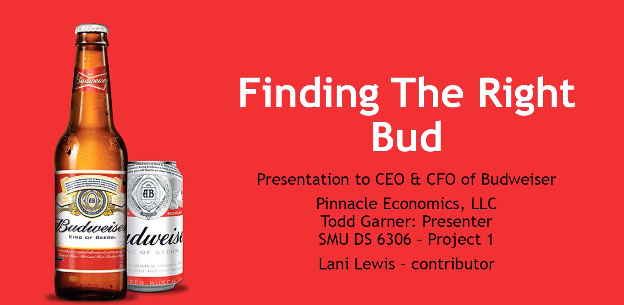

Good job including an agenda!

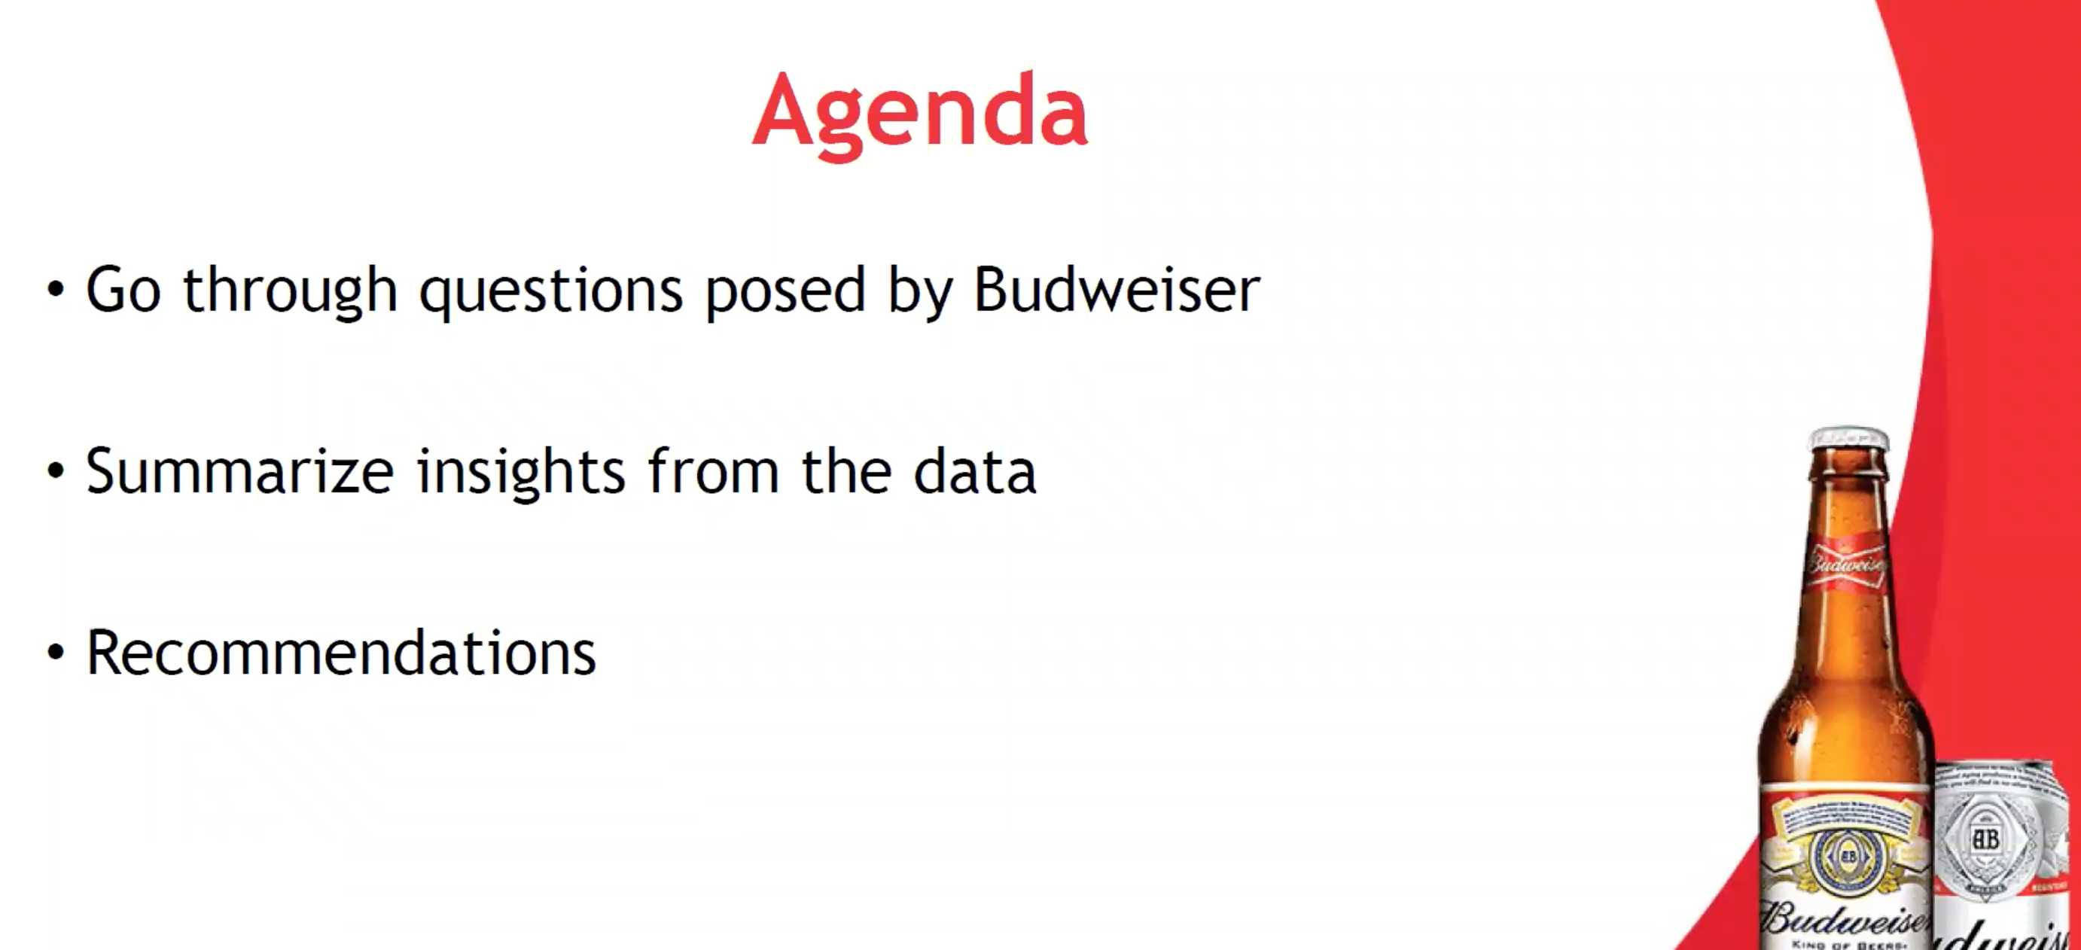

Beautiful slide… very professional.

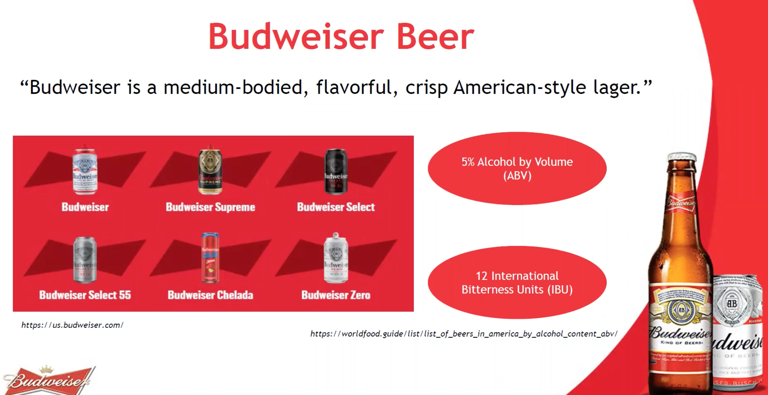

A useful addition is to add the numeric values on top of the columns. Another would be to add the number of breweries per capita.

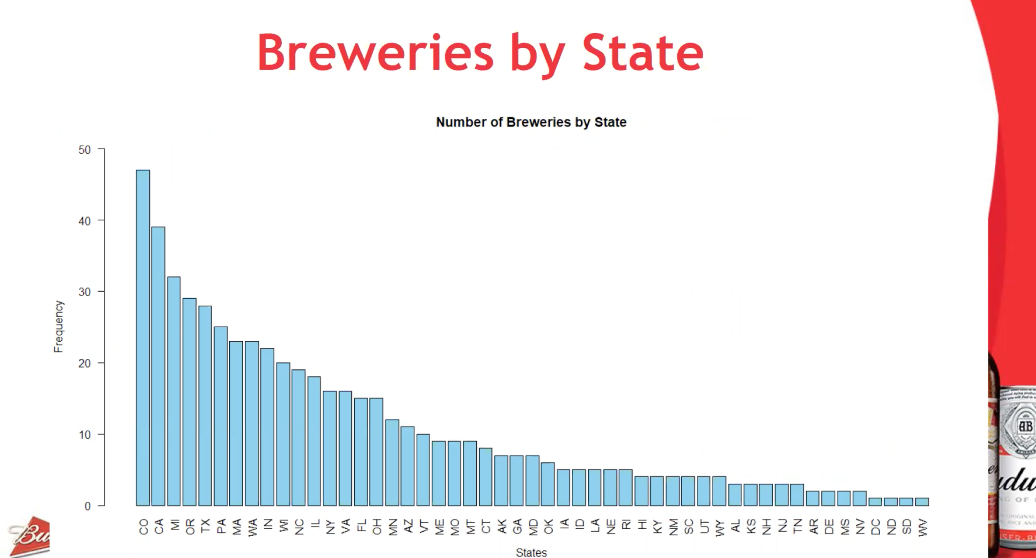

Nice work on this plot … good idea.

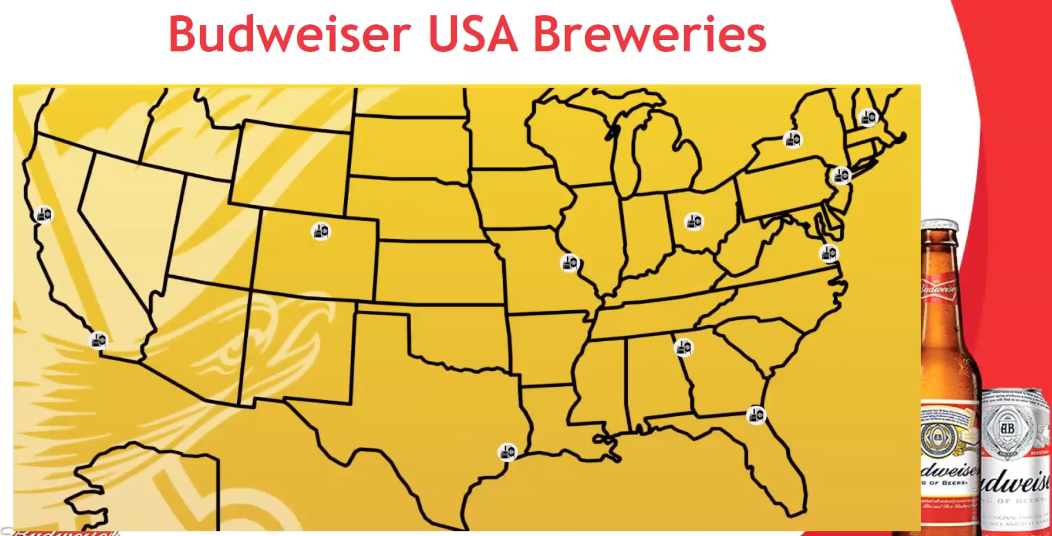

Good job addressing the missing values.. note that imputing the median will affect the standard deviation although correct it will not affect the median… however it will affect the average. It would be useful to report the percent missing overall as well.

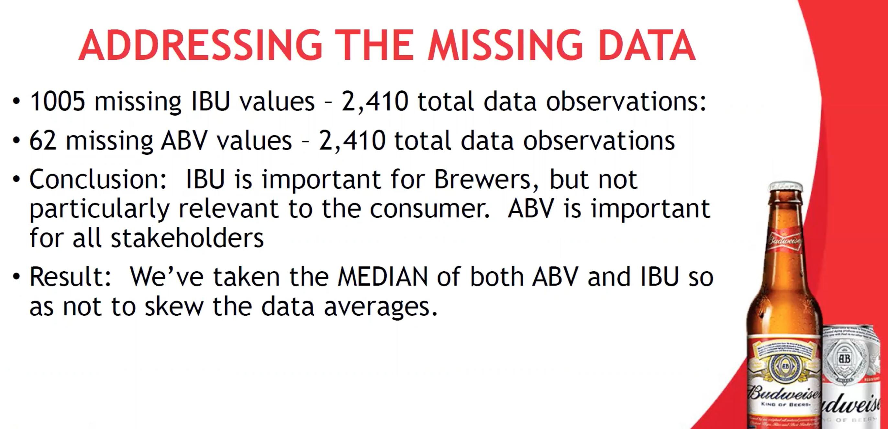

Good work here.

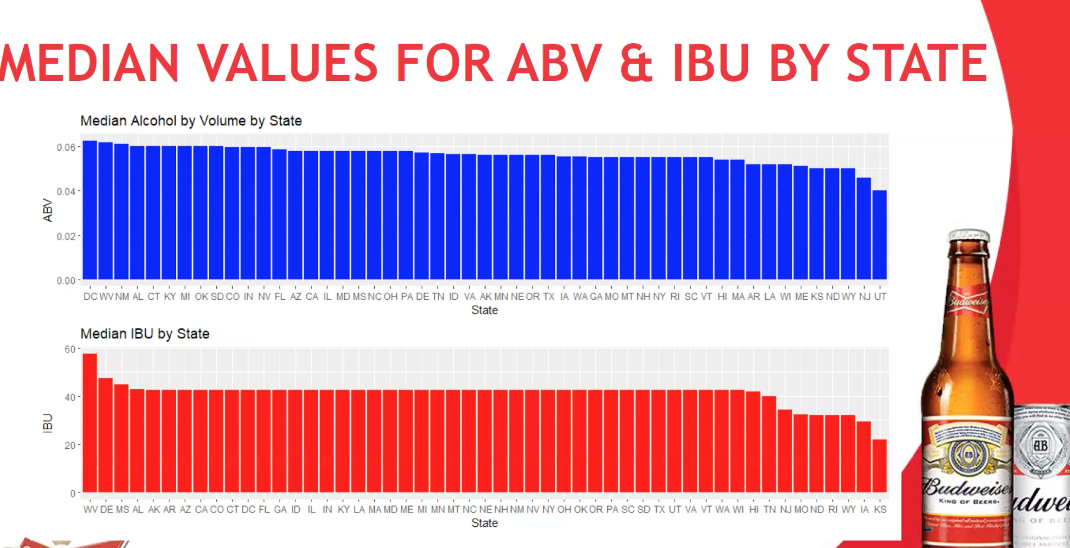 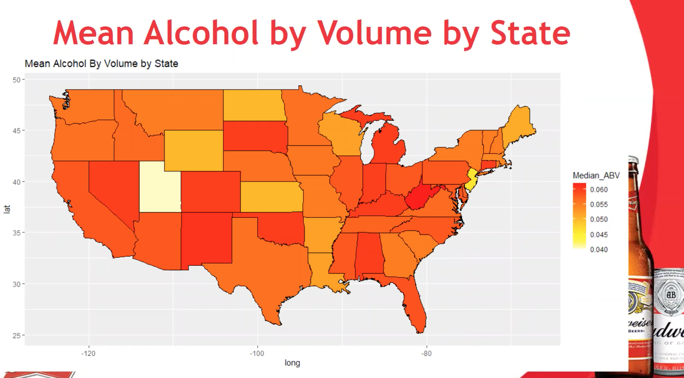

Same here … many have added pics of the logo / beer which I have found to be effective.

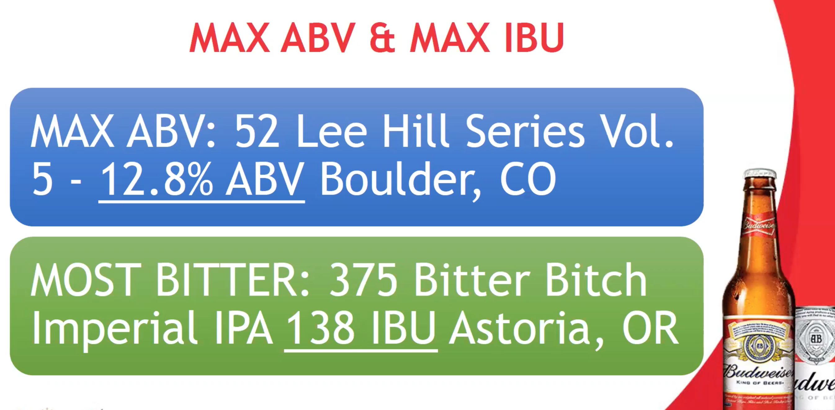

Good slide… how do we know the last 4 have increased in market share? Someone will likely want to know the source of that information.

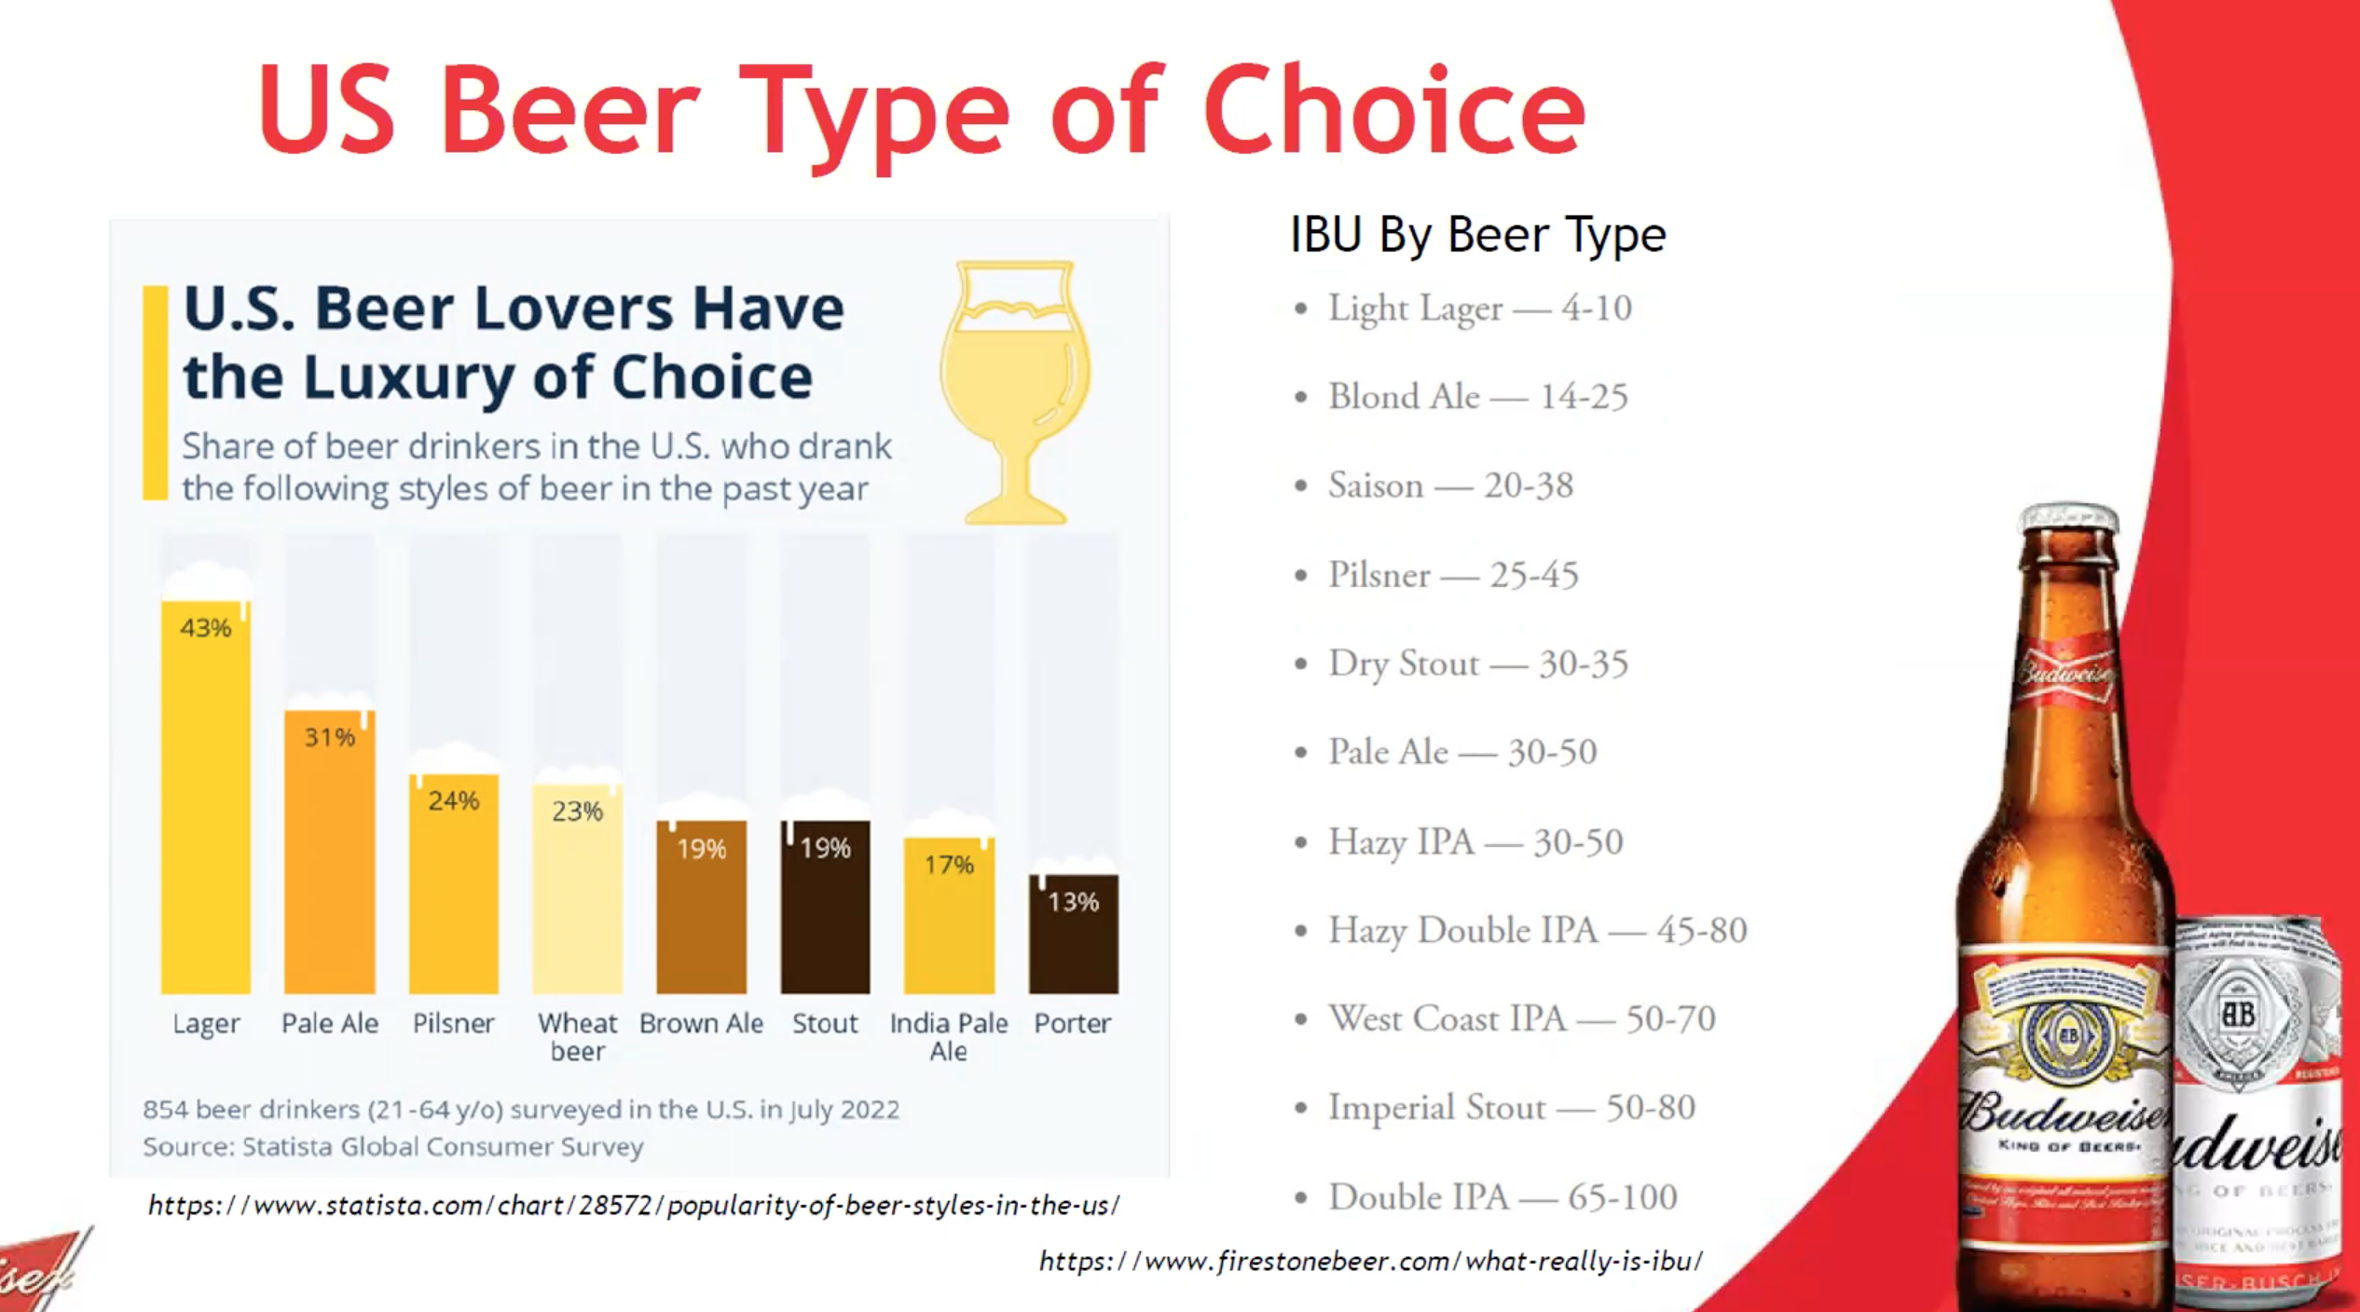

Something is up here as in a left skewed distribution as it apparent here (as you said) the mean will be less than the median … the mean looks greater? Most other groups have a right skewed distribution here.

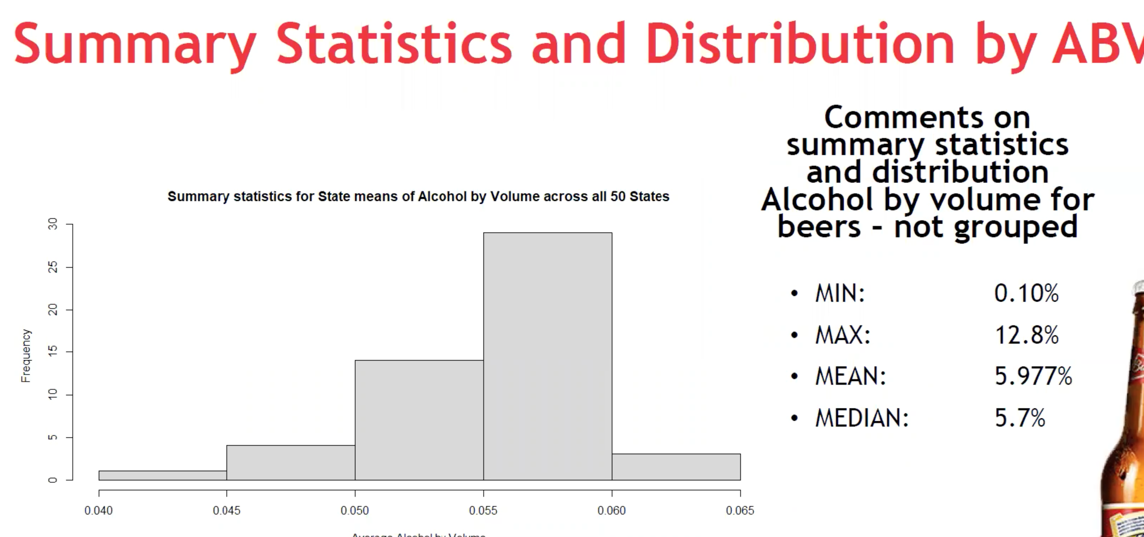

We want to be careful by saying there is “definitely” a positive correlation… however, it could be argued that this is a census of beers in the nation and that this is a look at the population rather than a sample… the takeaway is be very careful with the word “definitely” and be able to defend the use of it.

What we definitely can’t say is “the higher the IBU the higher the ABV. There are several counter examples of this on this plot. This was a noted point in Unit 10 and will be a HUGE and reiterated point in Stat 1 and beyond.

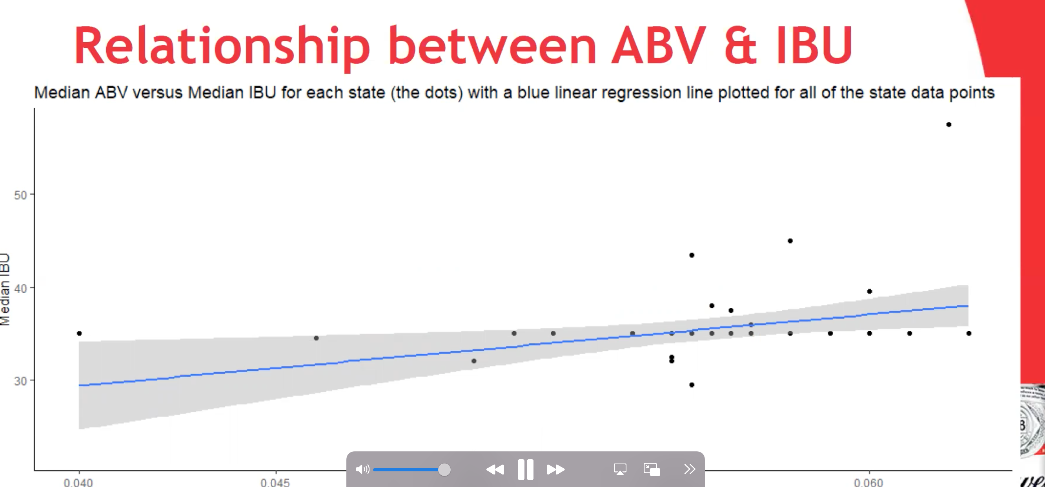

There was a delay in talking about this slide from where we could see it.

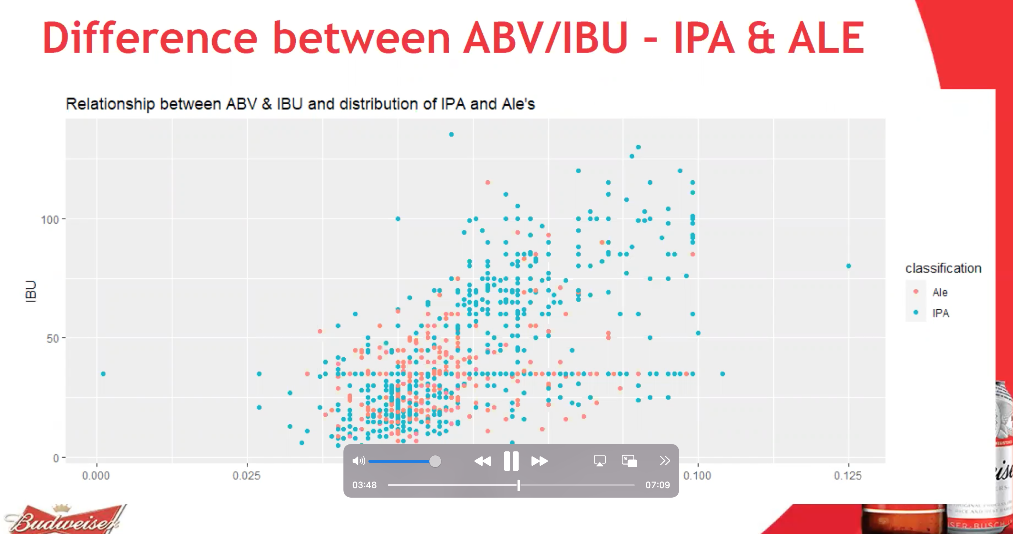

Great reference to Spuds McKensie! Seriously.. bringing up Joe Six Pack and other marketing campaigns will no doubt land with the c-suite.

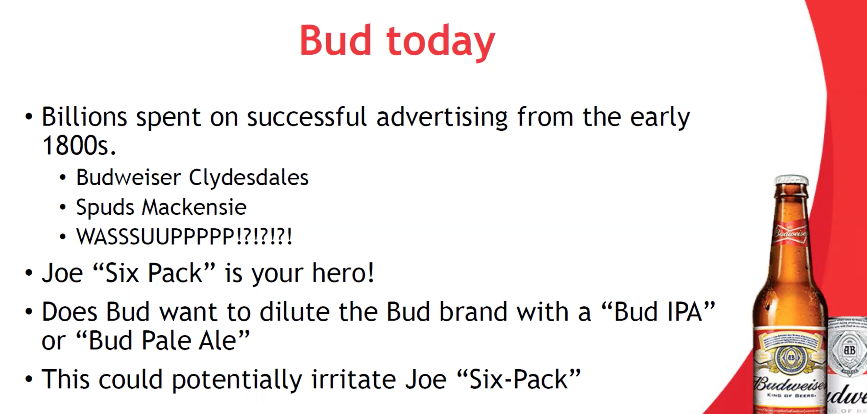

Great insight in to the business case and market research.

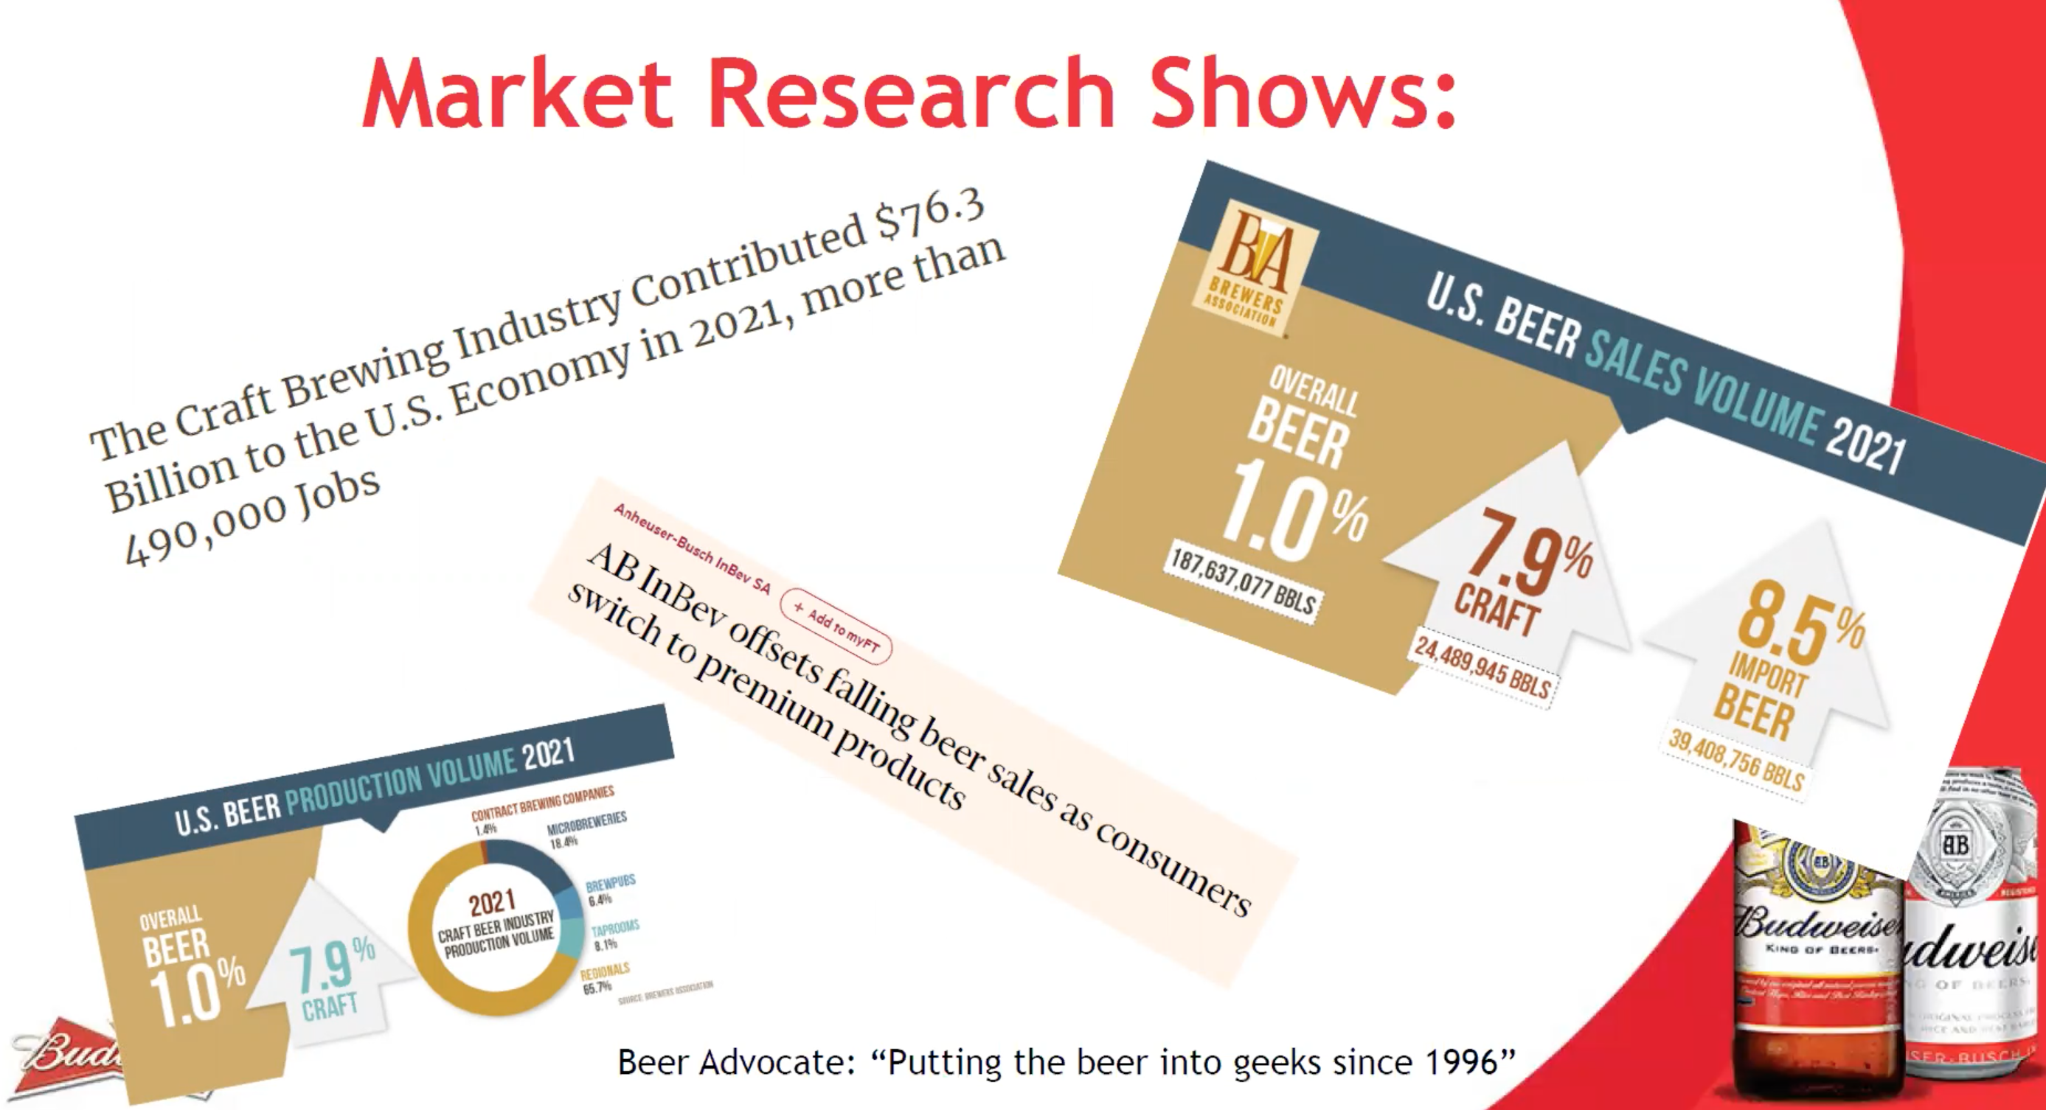

Great work here.

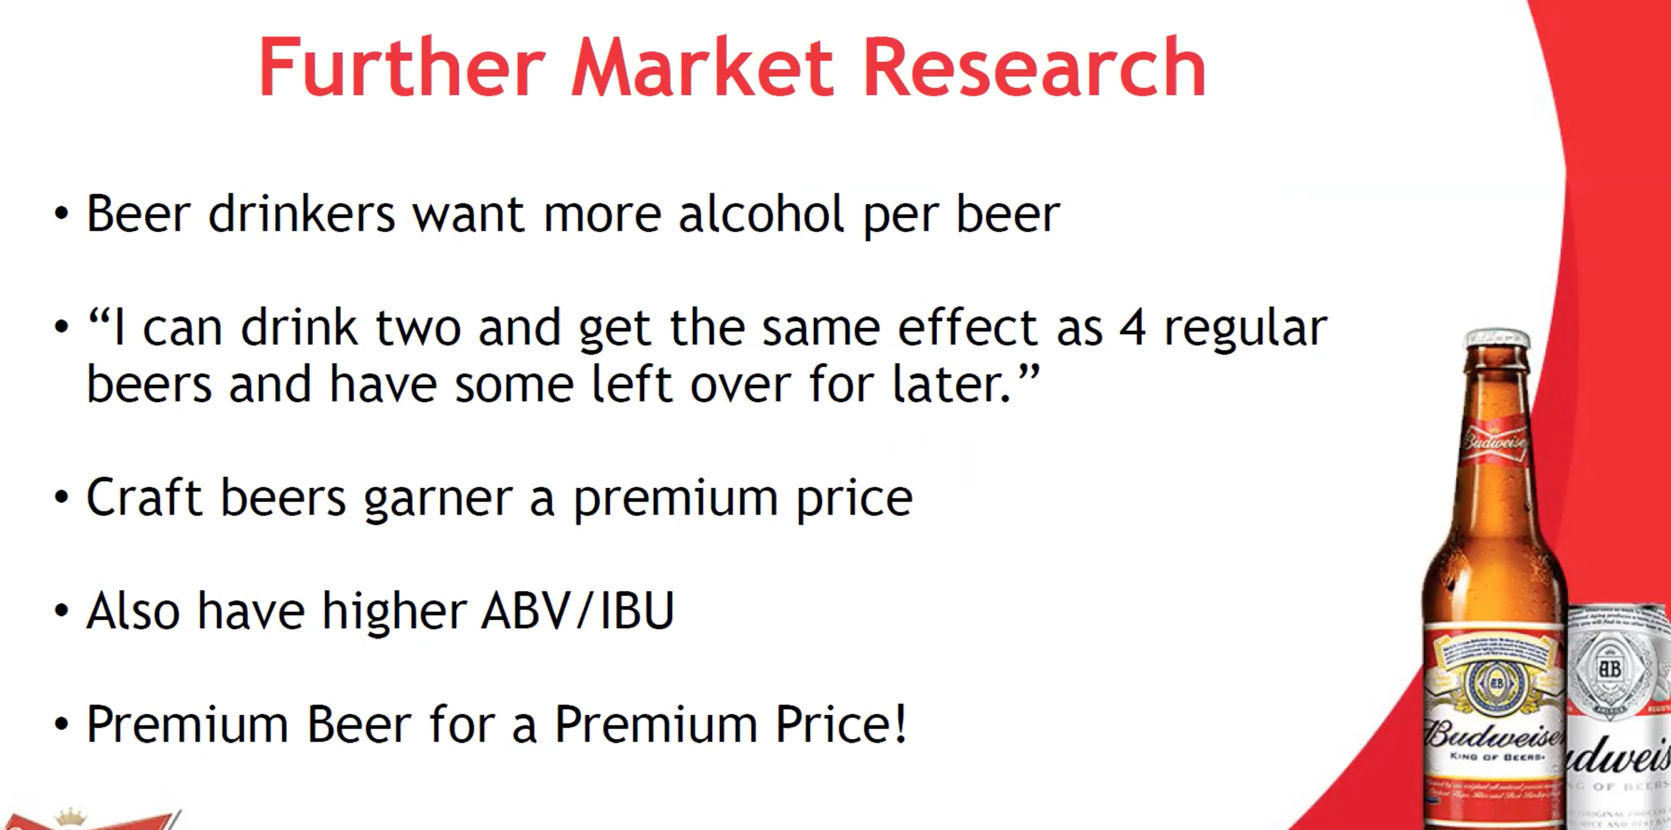

Great job here… I know it would take a while to get this information .. but making these statistics per capita would be one way to provide more useful information.

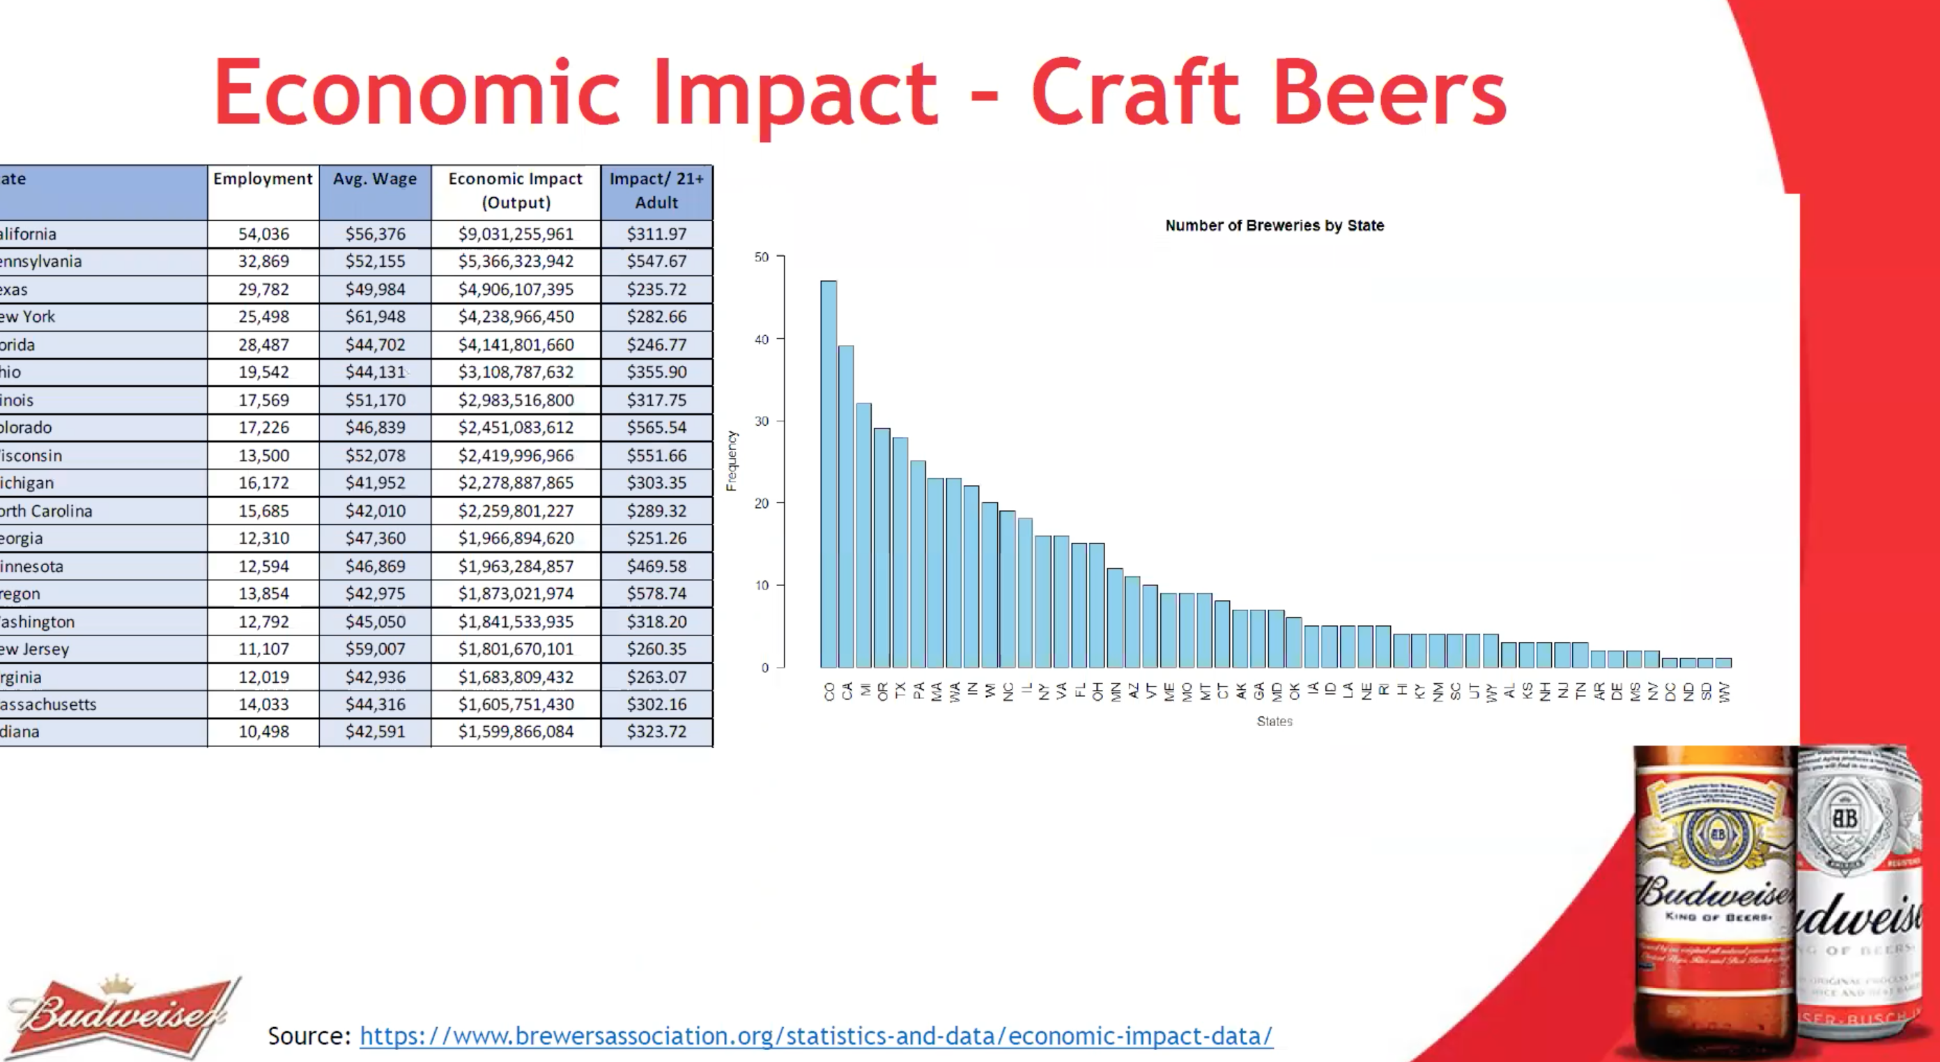

Great job with the exit and the recommendations. I would recommend adding your email to this slide … but that is just a recommendation.

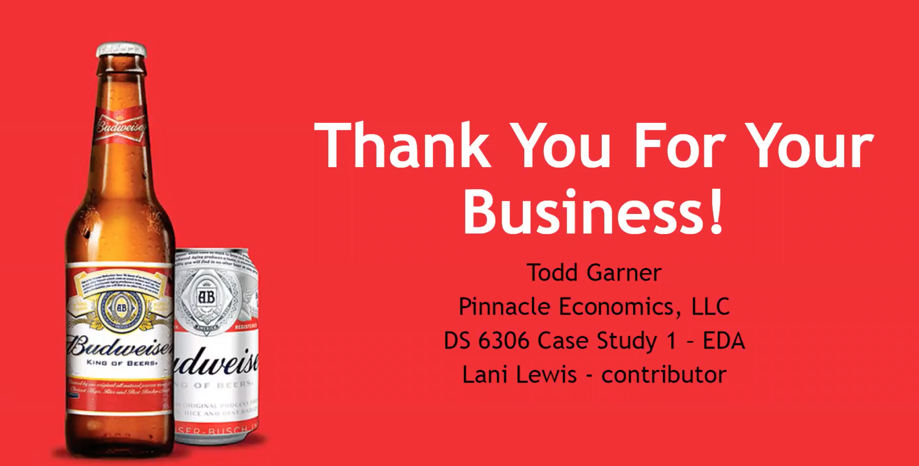

Great work Todd… you added your own unique style to the presentaiton and your experience, creativity and talent were all present in the analysis and presentation. As you go through the program, I encourage you to pay close attention to the detail of each interpretation … this detail is where a lot of the business value comes from in my opinion and is often missed by data scientists and statisticians… to to their and their customer’s detriment. Small details can make big differences. Great work!

**RMD/ Answer to Analysis Questions – 58%** / 60

* Each team member will receive the same grade for the analysis / RMD and possibly analysis on PowerPoint deck (if same deck is used.) If there is division of labor, it is assume that the each team member is double checking and is very familiar with the response to every analysis question.
* 9 Analysis Questions: not equally weighted. The harder questions are worth more points.
* Taking off for cumulative errors will not be a thing, provided the answer is well-reasoned based on prior questions’ answers.

**YouTube / Zoom Presentation** – **19%** / 20%

Communication and presentation of your findings are critical to being a successful data scientist. You will be graded on:

* + Voice inflection
  + Content Knowledge
  + Slide Organization / Content
  + Visualization
  + Periodic eye contact and general interest in your audience. (Your face must be visible during the presentation.)
  + Composure: This will be mostly **not reading** off of the slides.
  + Pace: Not going a second over 7 minutes. The CEO and CFO are very strict on this point.

**GitHub / Documentation** – **10%** / 10%

* Sensible structuring (location) of files in repository
* Presence of Powerpoint, Rmd and knit files in the repo.
* Readme/Codebook
* RMD Documentation: Answers should be in a well commented and explained RMarkdown file.

**Peer Grading** – **10%** / 10%

* Send a review of your performance **and** your teammate’s performance to 2DS. You will do this twice during the project: one will be turned in to 2DS Unit 8 and again in Unit 9. Honest (but not rude) appraisal is fair game. Your review will **not** be shared with your teammate. Give them a score from 0 to 10. Most people should fall between a 6 to 10 (D to A) range. 5 or lower (F) is reserved for particularly difficult teammates. Grade your own effort on this metric as well.
  + This metric should not be a measure of your partner’s coding ability, but the amount of effort they put in. If they are well-meaning but make mistakes, that is not cause to dock them points. It should be reserved for no-shows, careless work, or laziness.
  + Make yourself available and accountable. By signing up for this course, you committed and will *need to* *make time* to work on the project*.* We are all busy adults; you must manage your time well and meet halfway on your partner’s schedule.
  + Failure to turn in a review will result in a zero for this section.